Screenshots illustrating each cleaning/processing step

- Data cleaning : Removing duplicates.
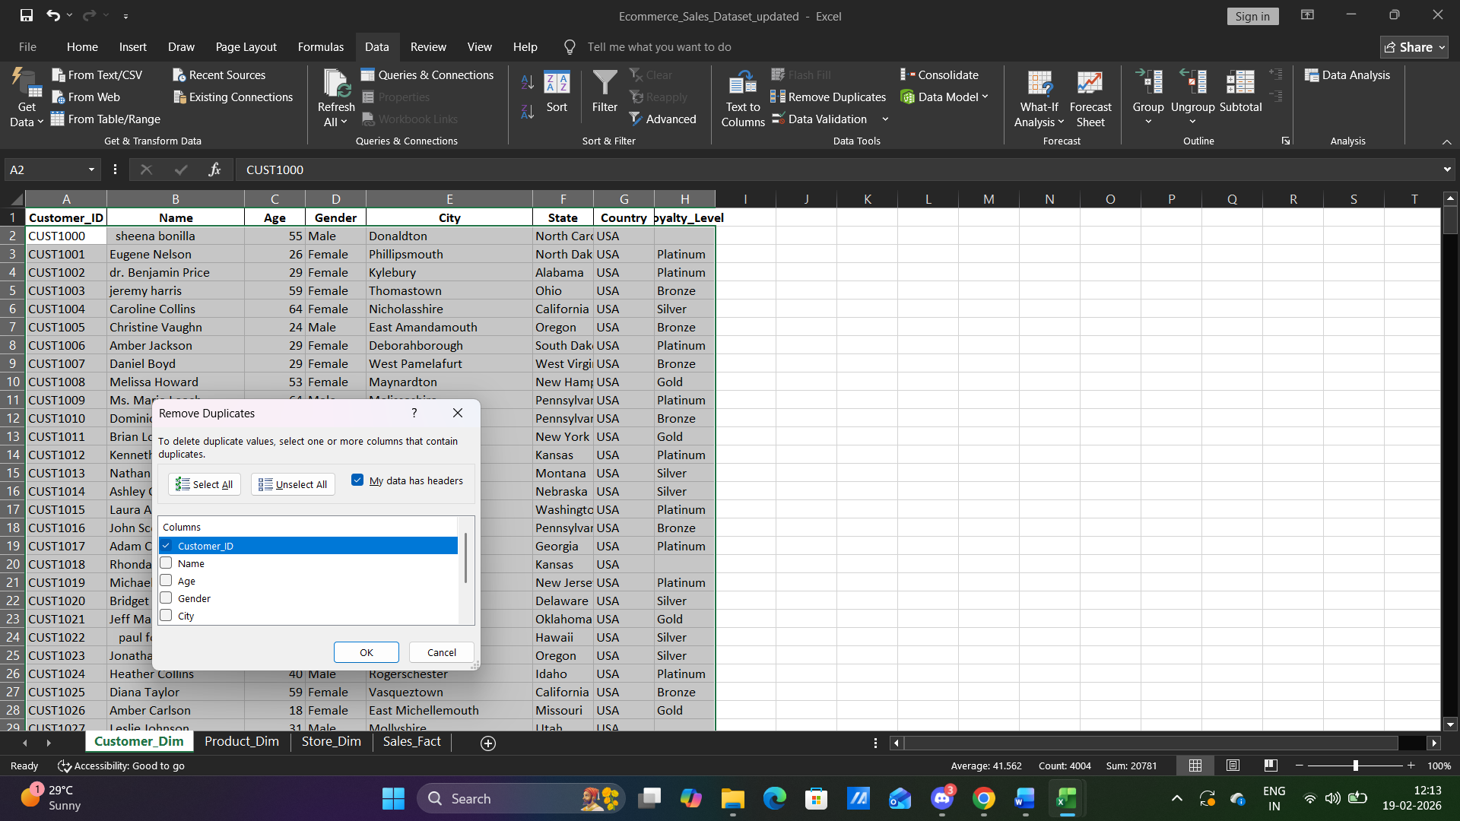

- Correcting Text format using formula and cleaning unwanted space in data.
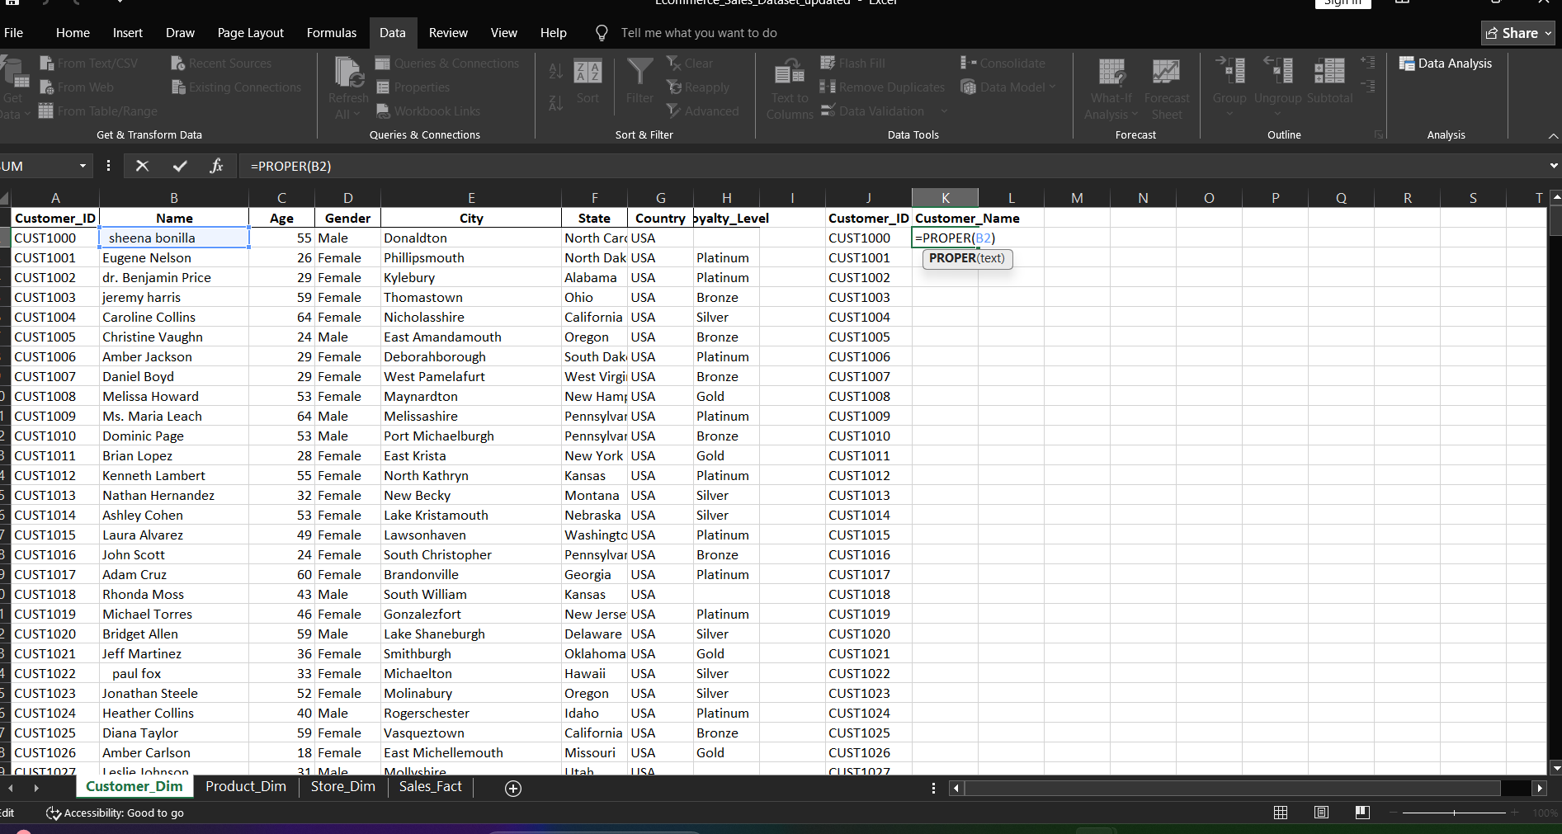

- Finding the missing dats using formula.
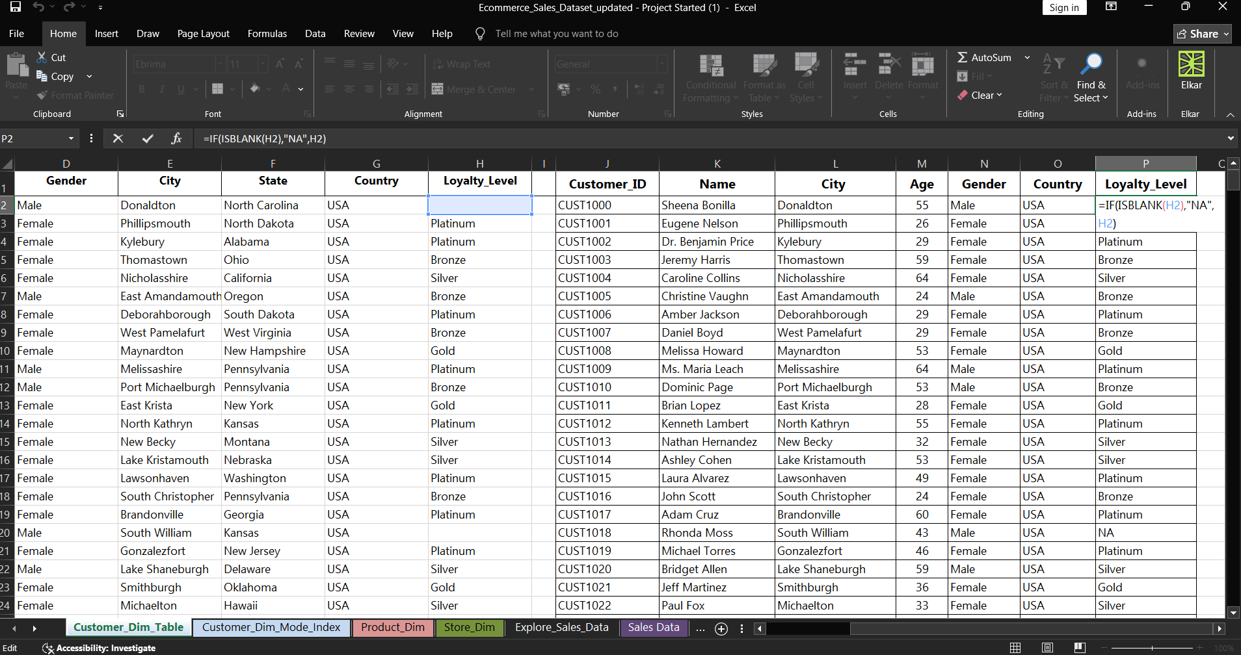

- Creating tables using corrected data.
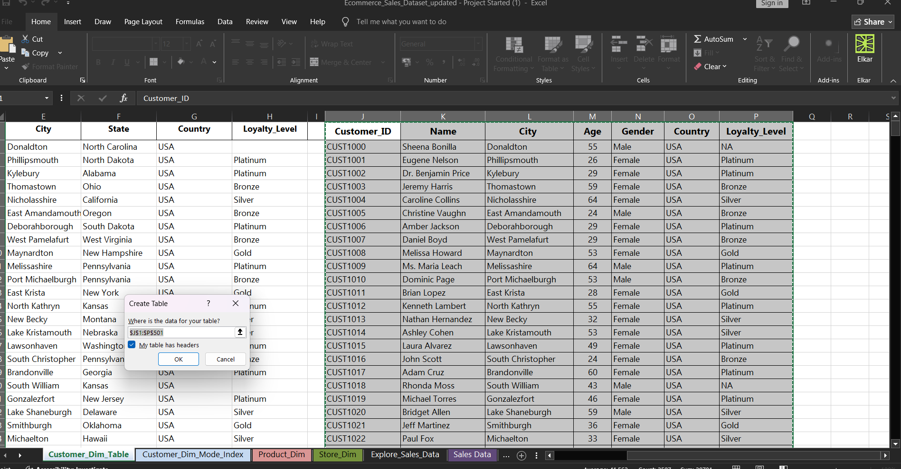

Output result of tables
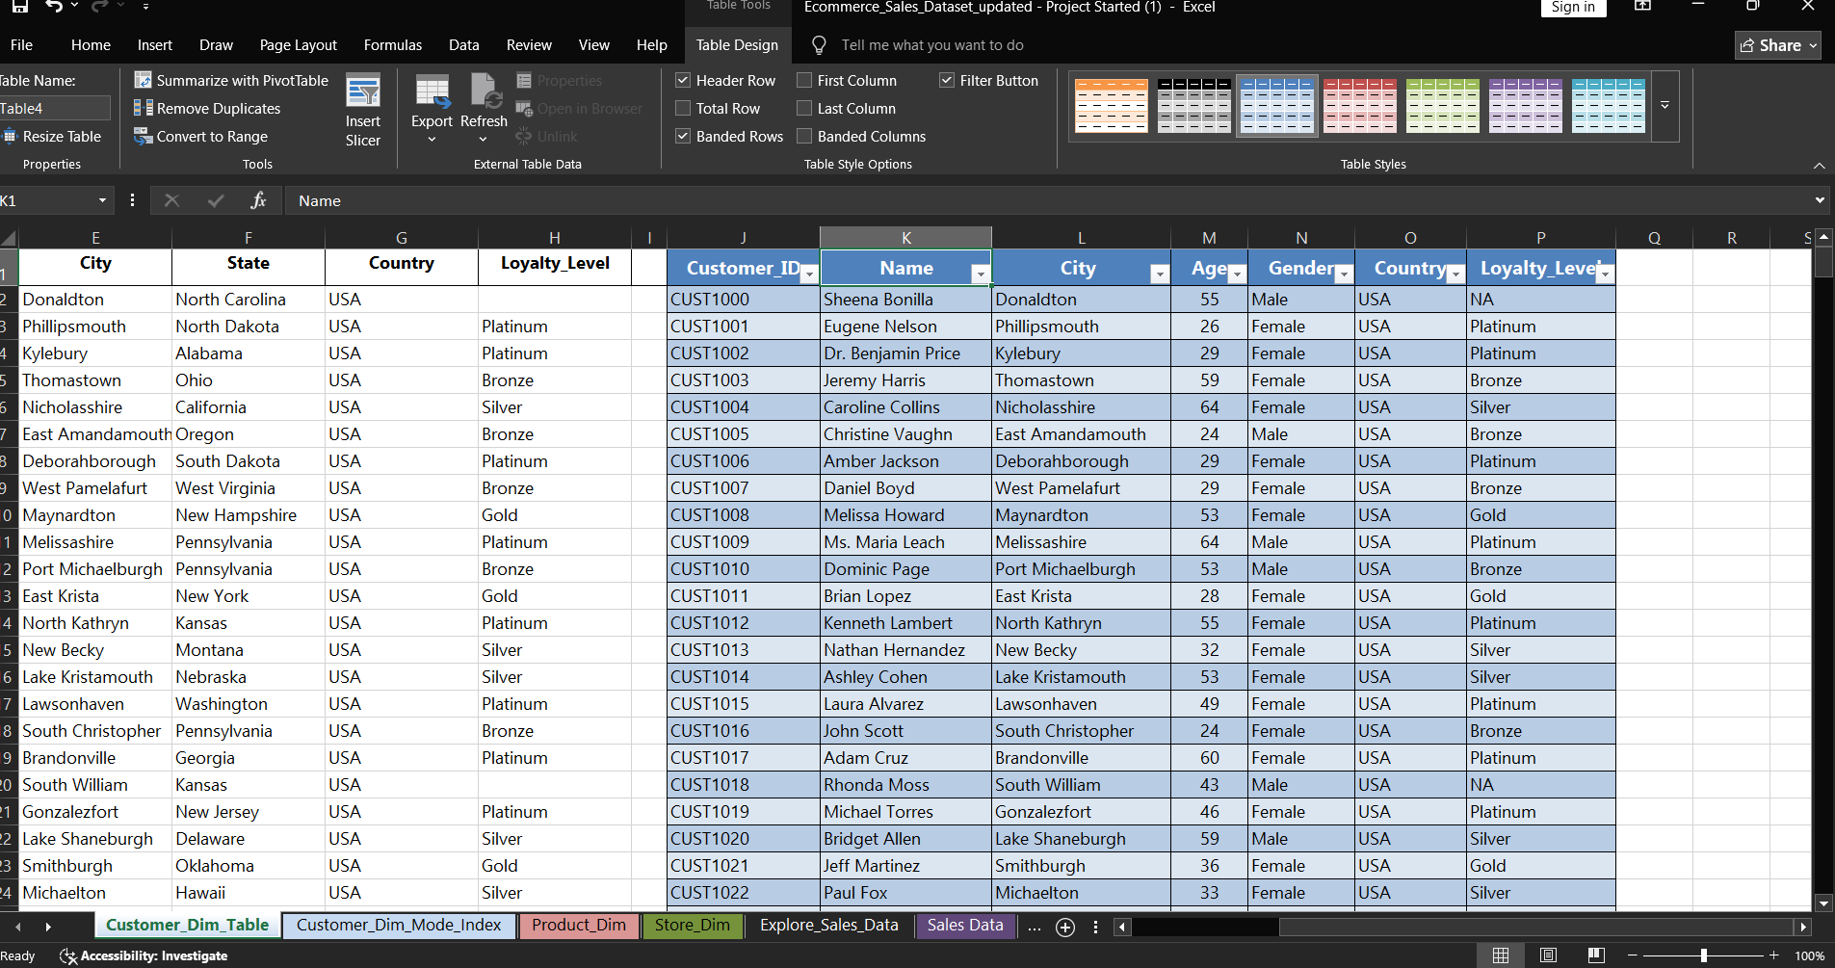

- Ecoding, index and mode formula to find the Gender. Created data from the Customer Dim data sheet by own.
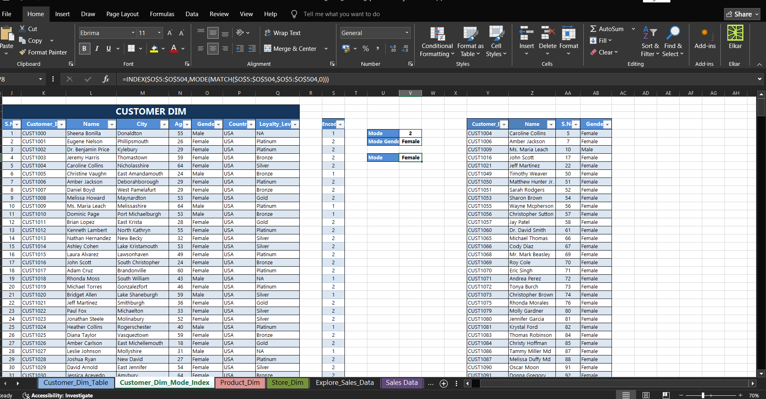

- Finding the missing cost and stock using formal in Product Dim sheet.
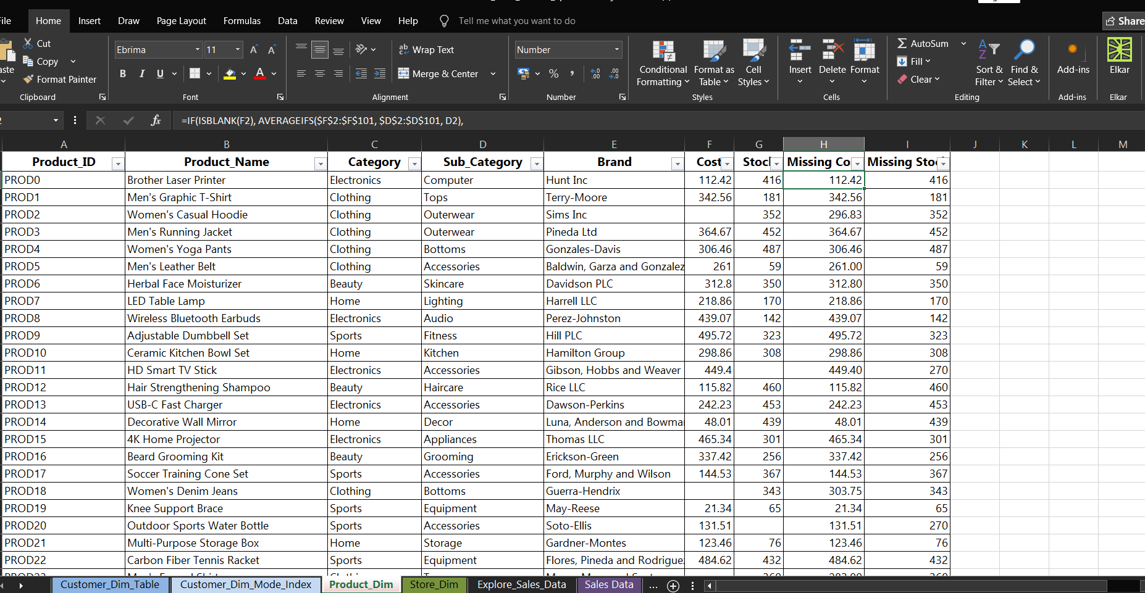

- Finding Missing Quantity, Discount values, Unit price, Total amount, Splitting dates using formula.
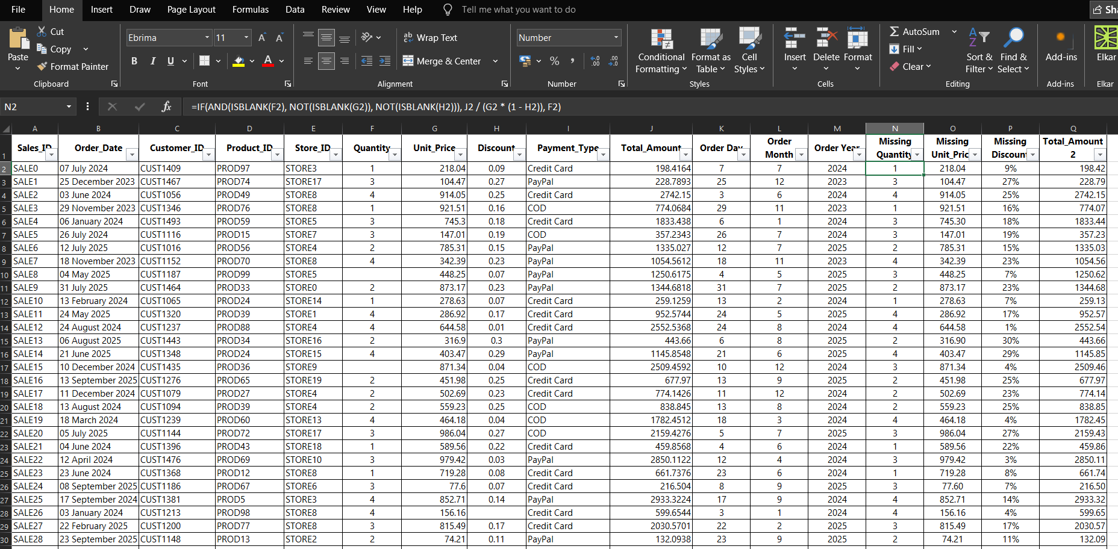

Final o/p after applied tables in Sales data sheet.
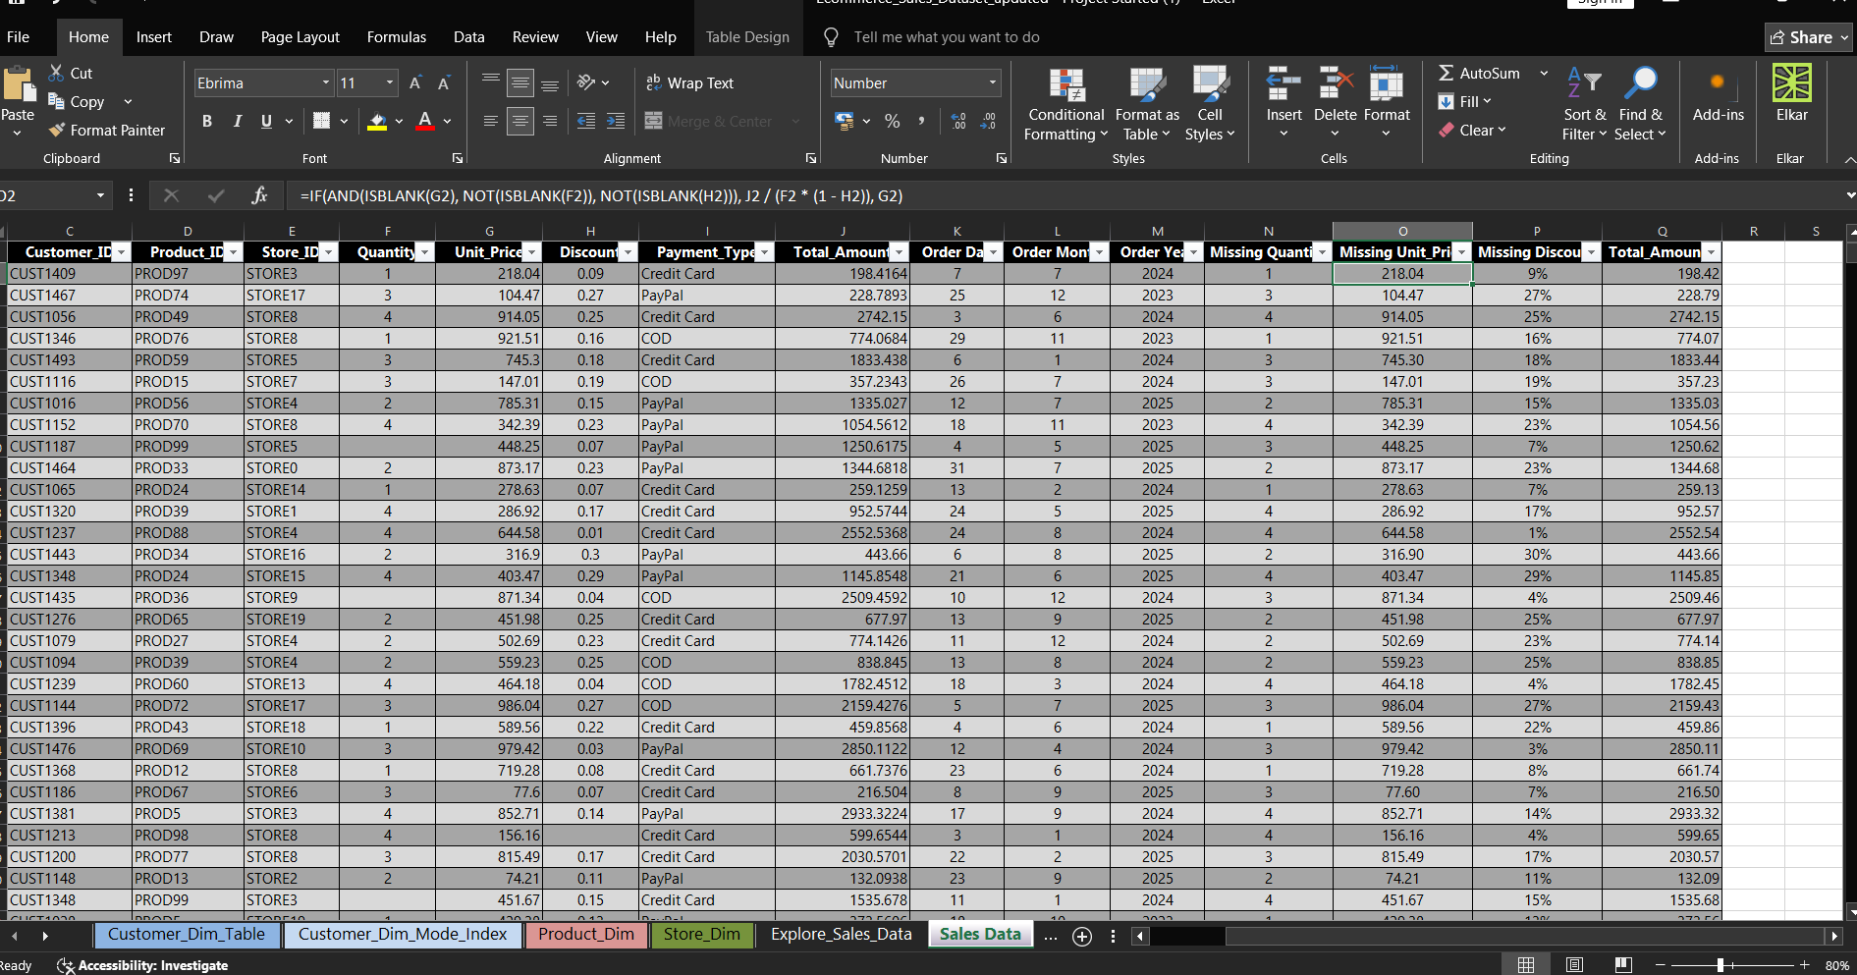

- Vlookup functions to combine the tables.
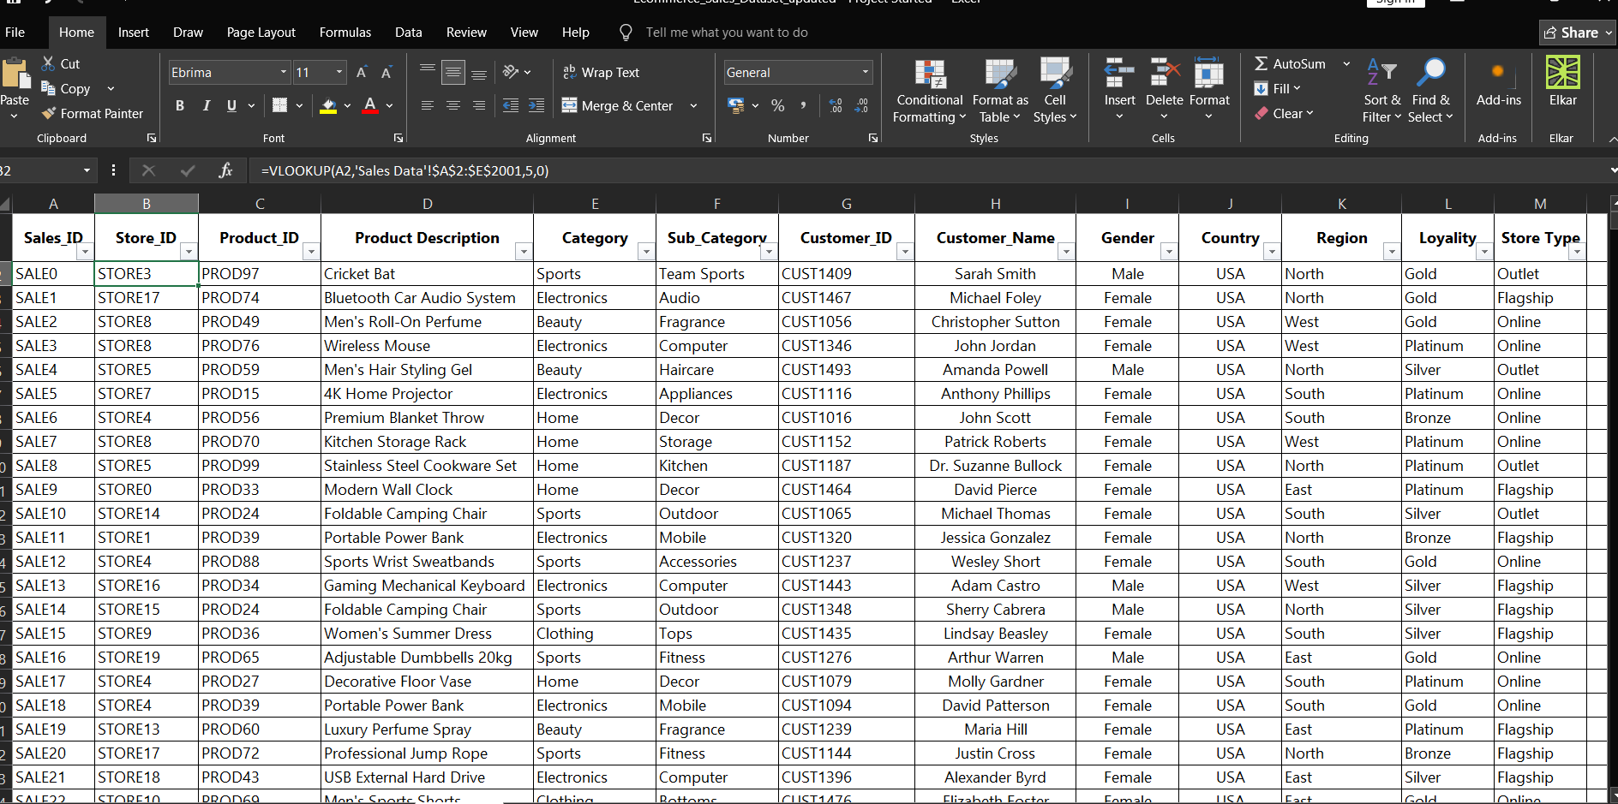

Final O/P
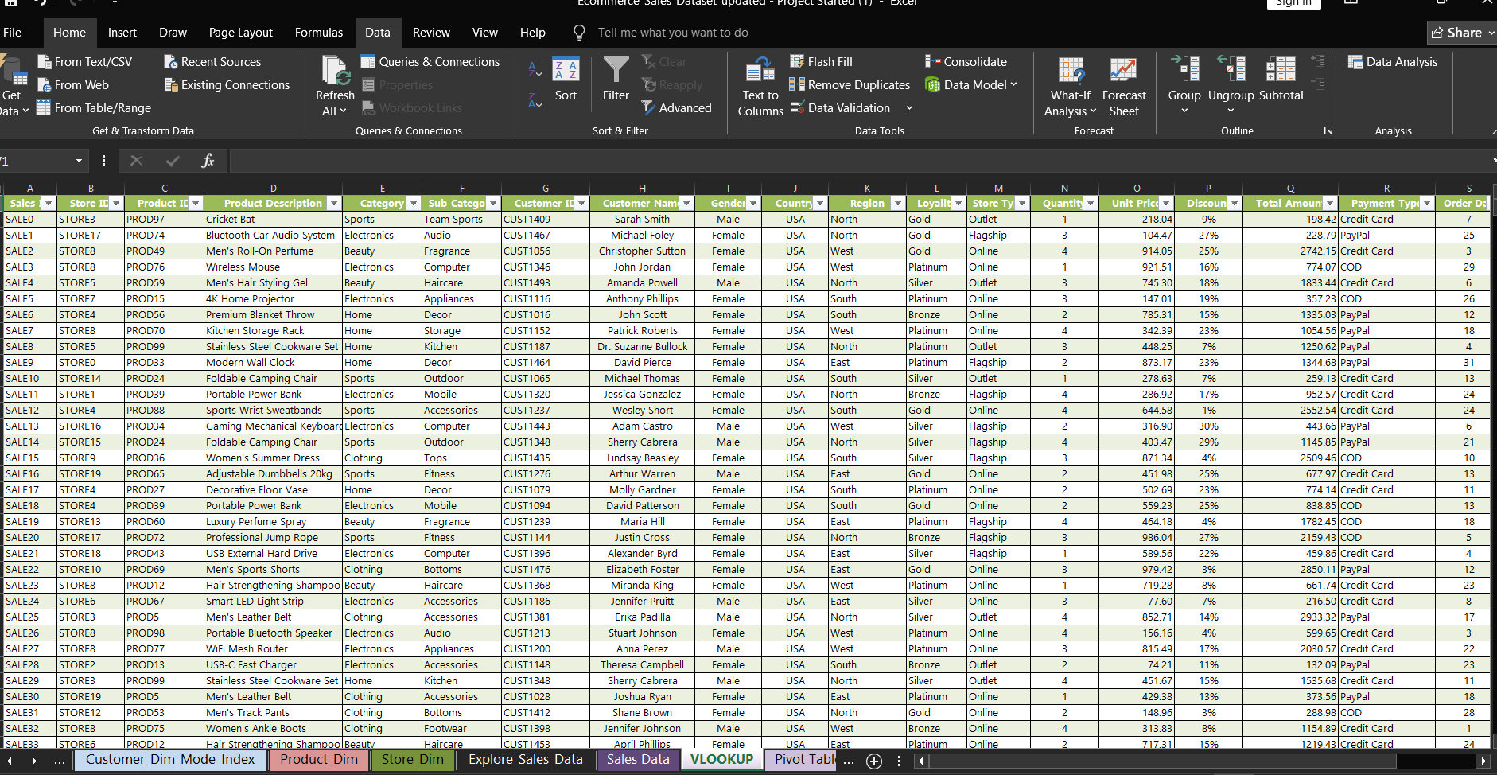

- Using Pivot Tables from vloop sheet.
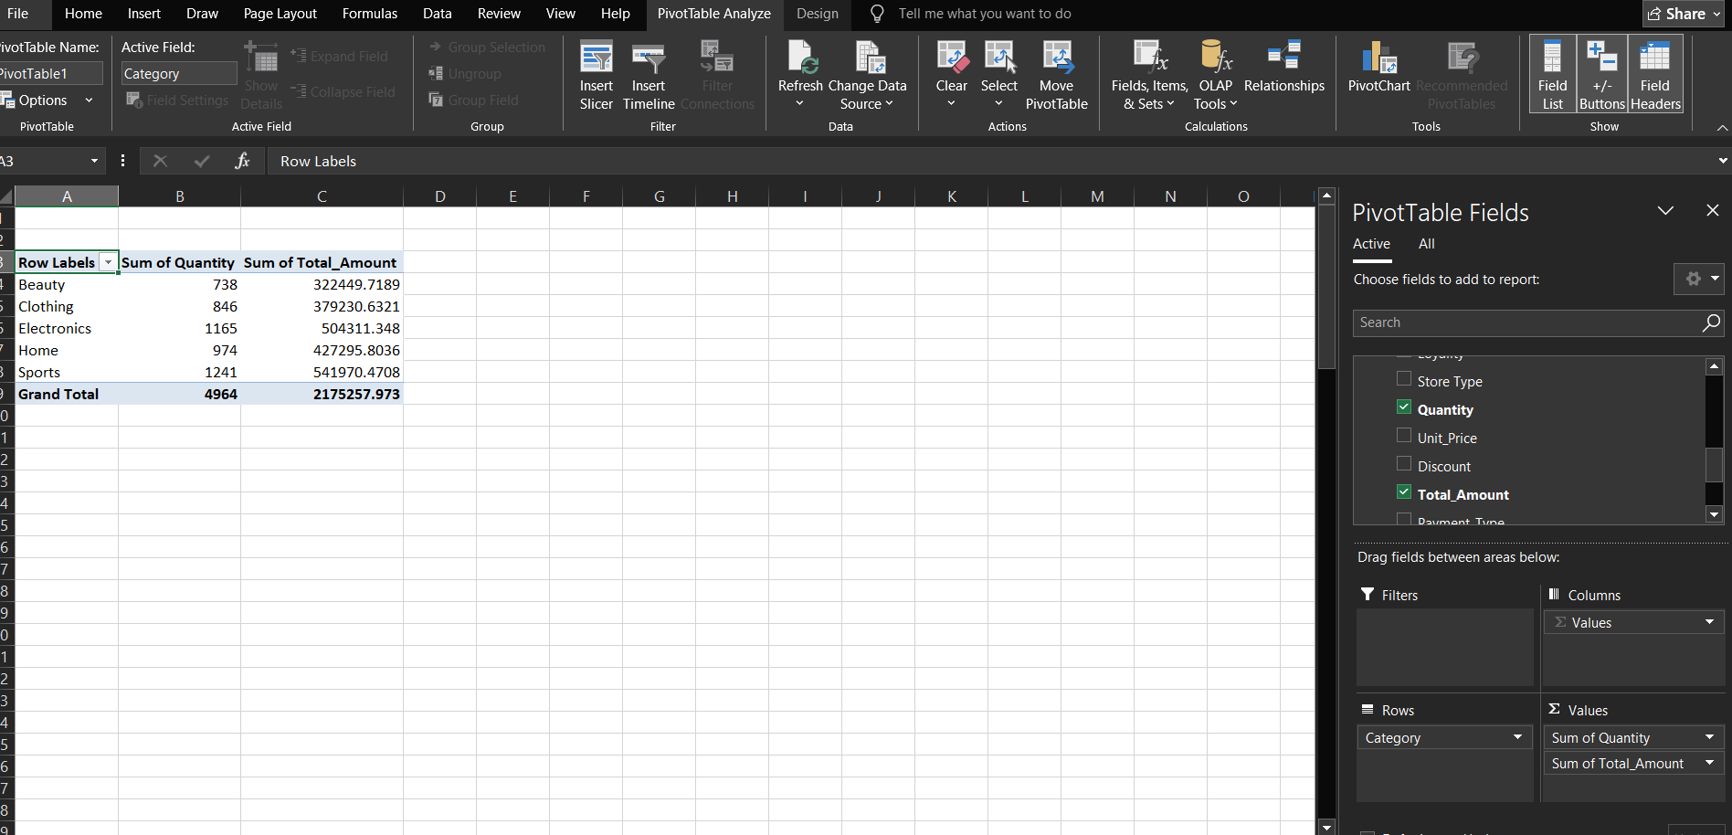

- After using recommended chart. Here, using Pie-chart to find the categorywise sales.
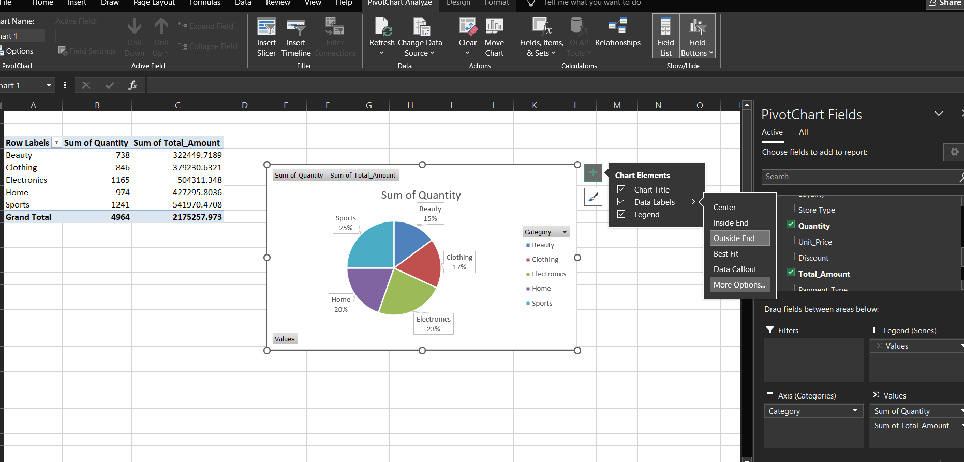

- Final o/p of Pivot Tables Sheet and Pivot Charts sheets using Data.
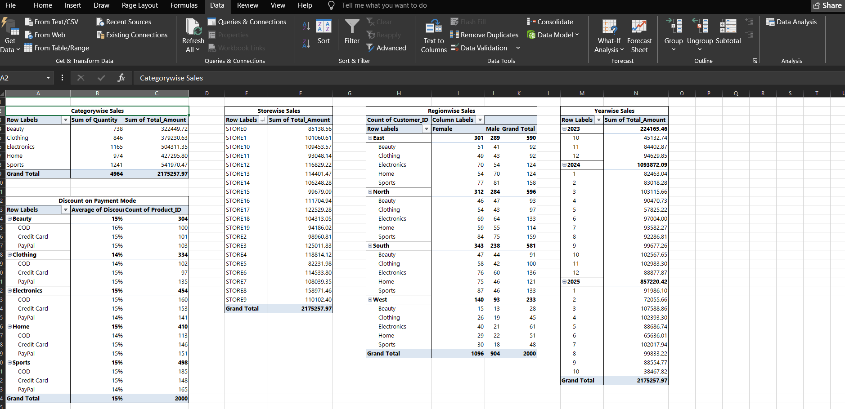
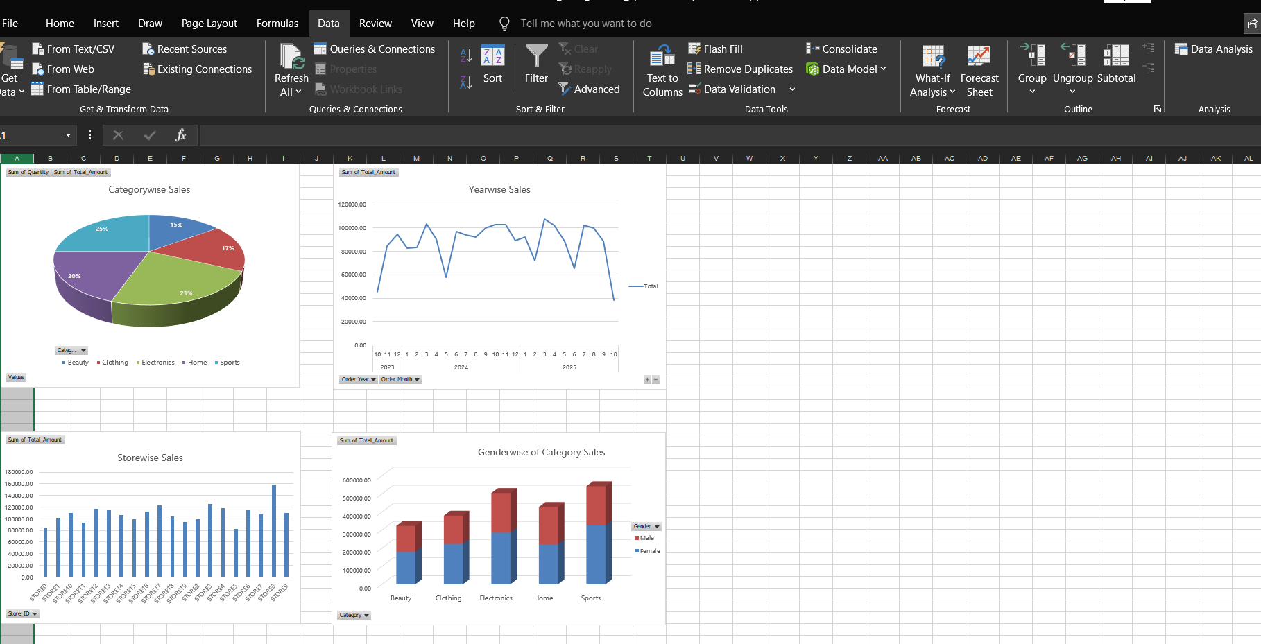

- Creating Dashboard Uncheck Gridlines, Filled color.
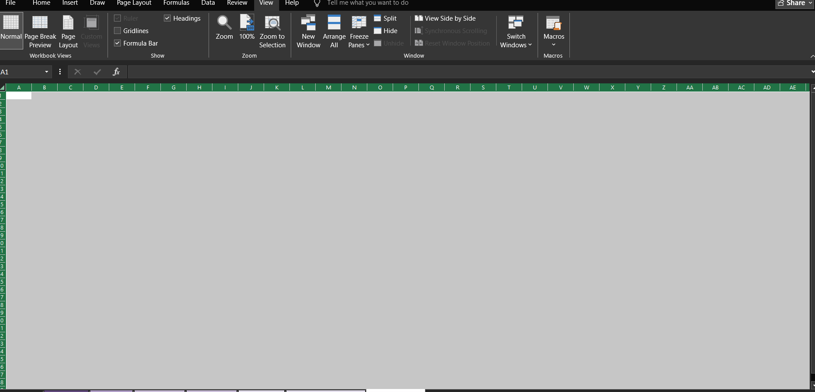
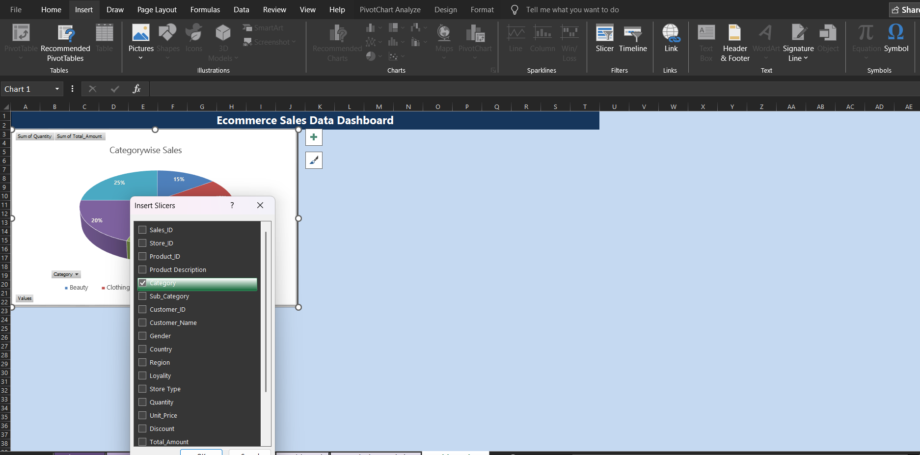
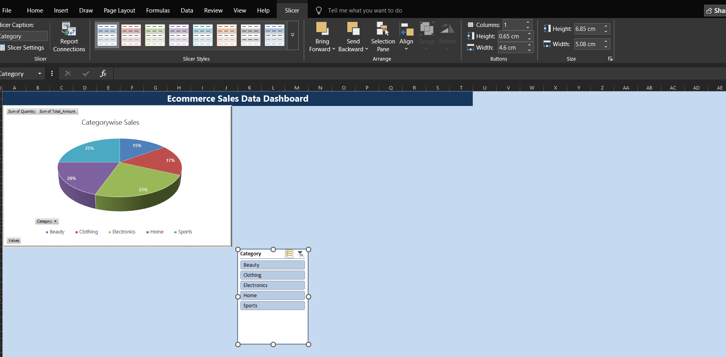
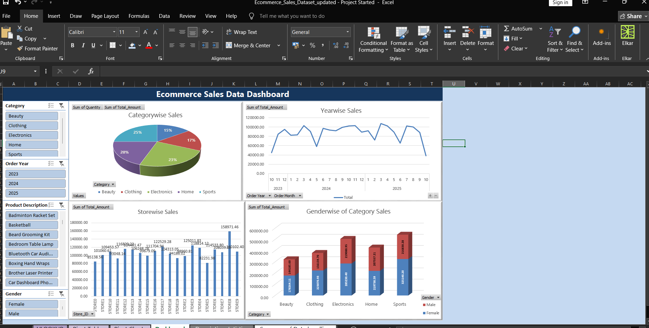
Conclusion: Final O/P of Dashboard Done.

Thanks

